AE 4610 – Lab 3 data

1. a. Initial Roll gains -  Kd = 25.4594, Kp = 29.3417  
   b. Initial Pitch gains - Kd = 33.4062, Kp = 35.3998, Ki = 0.3540  
   c. Initial yaw rate controller gains - Kp = 1.4853, Ki = 0.0149
2. Isolated Roll, Pitch, & Yaw Rate simulink models and step responses, with both the plot and a capture of the information provided by the "stepinfo" Matlab function. For the report, you need only include the relevant stepinfo information (e.g. peak time/rise time, settling time)

Roll:

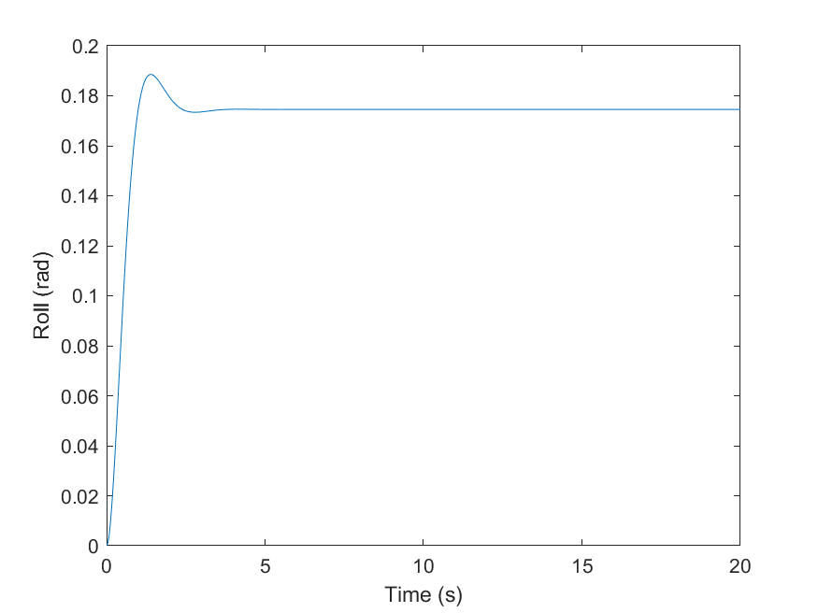

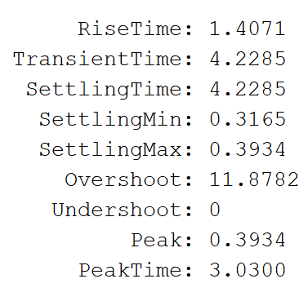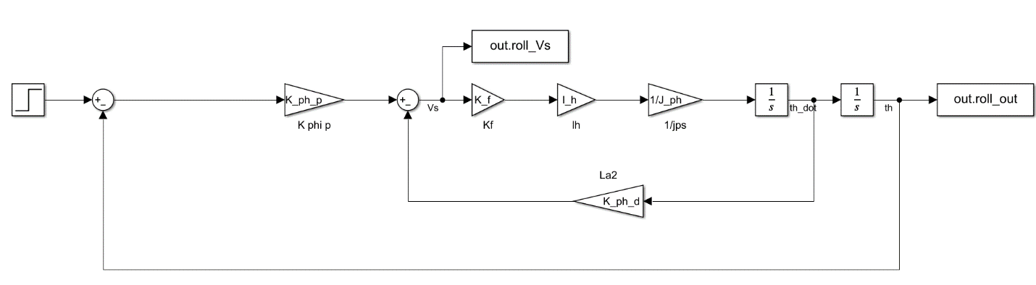

Pitch:

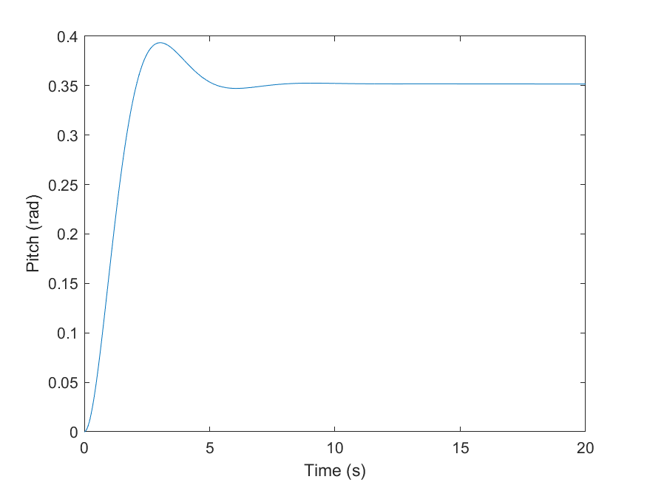

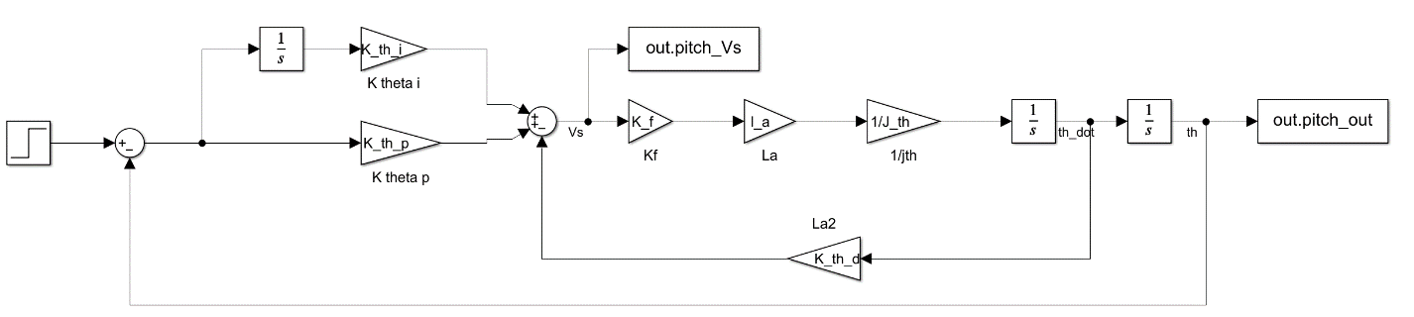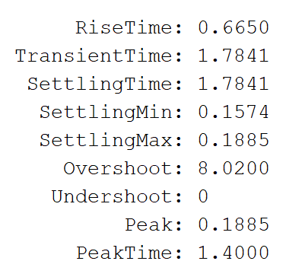

Yaw:

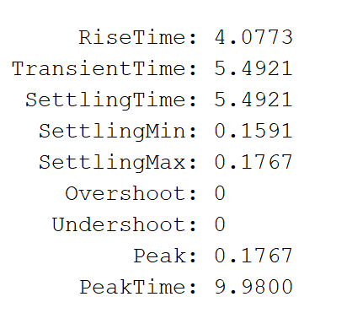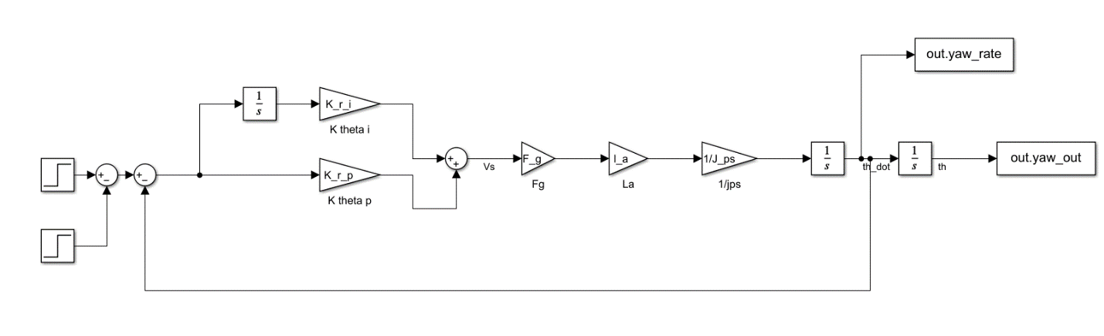

1. Combined nonlinear Simulink model, with the Yaw Rate step response validated with both a plot and "stepinfo" information

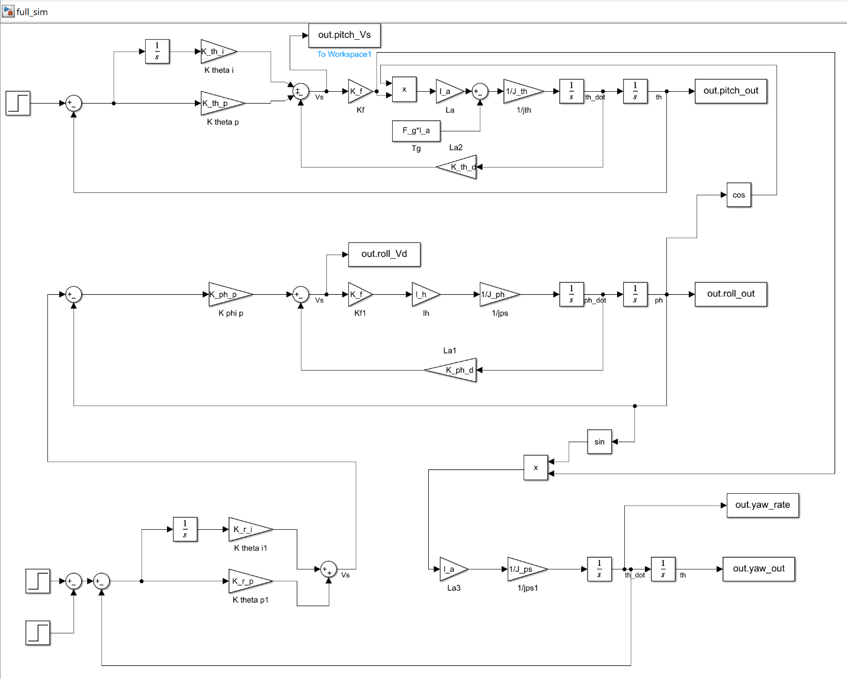

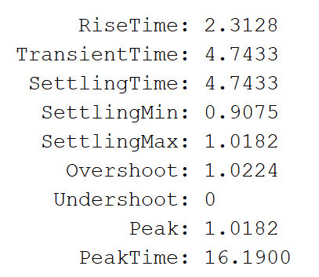

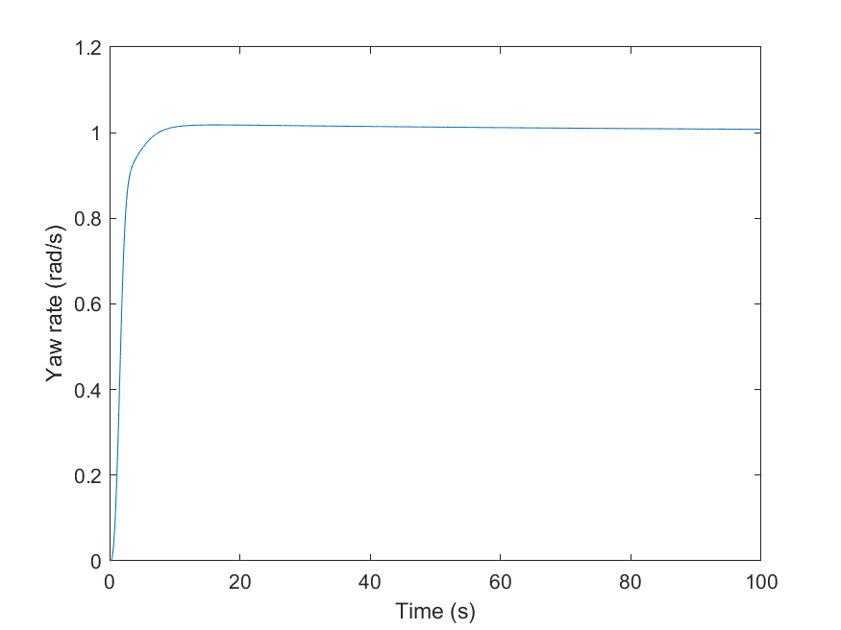

1. a. Final Roll gains -  Kd = 12.7297, Kp = 29.3417  
   b. Final Pitch gains - Kd = 31.7350, Kp = 35.3998, Ki = 0.3540  
   c. Final yaw rate controller gains - Kp = 1.0397, Ki = 0.0104
2. Pitch, Yaw Rate, and Yaw attitude plots for the case of Pitch command of 0 degrees

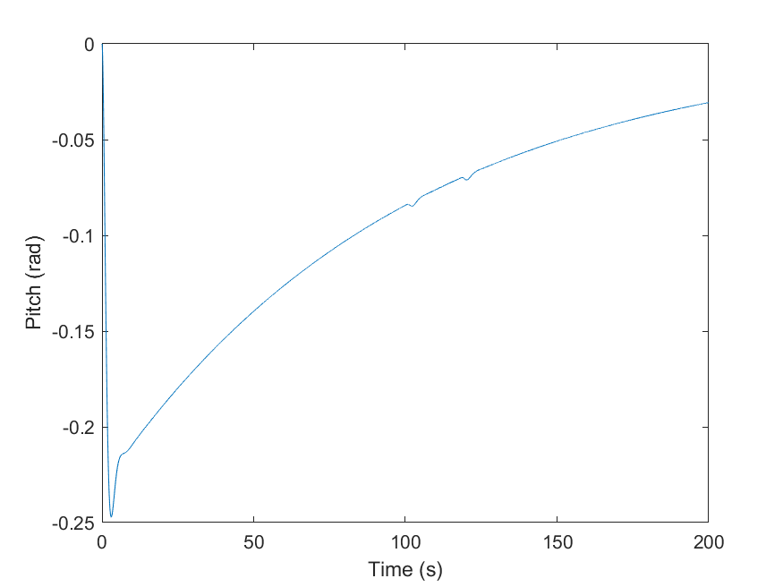

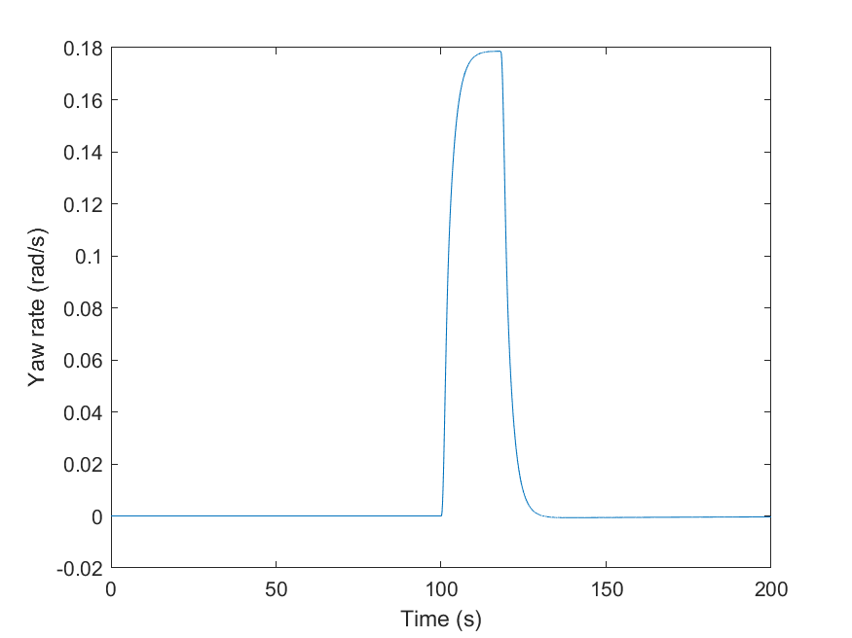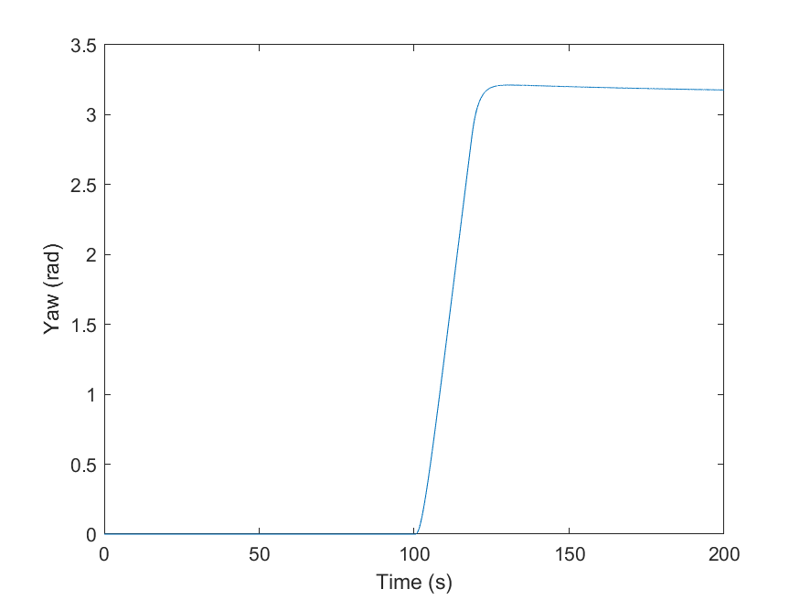

1. Pitch, Yaw Rate, and Yaw attitude plots for the case of Pitch command of 20 degrees

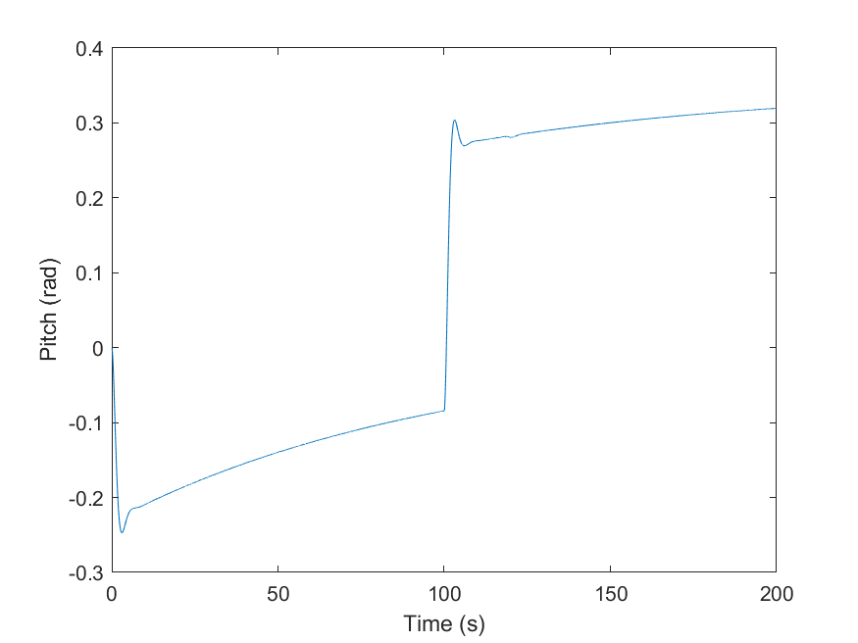

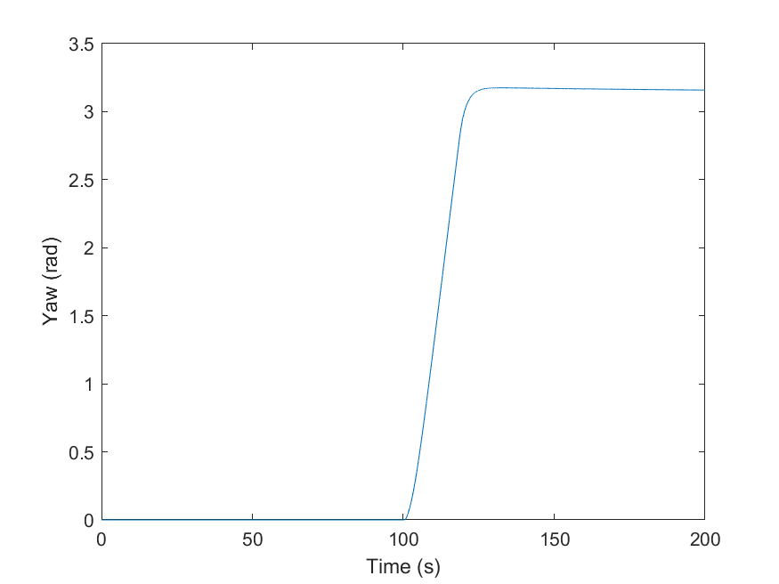

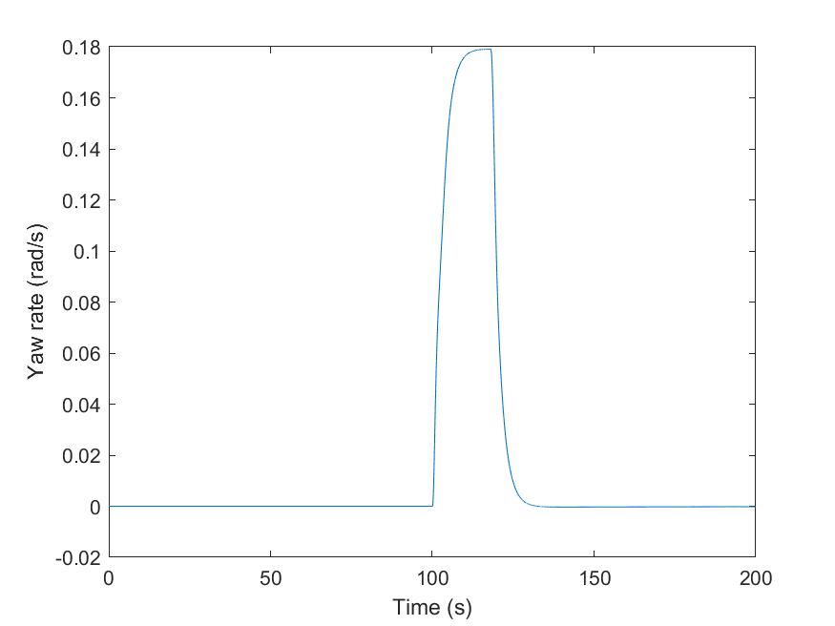

1. The length of time required for the 3DOF helicopter to rotate 180 degrees for each pitch command (list each time separately, even if you find the time to be the same)
   1. 18s
   2. 18s